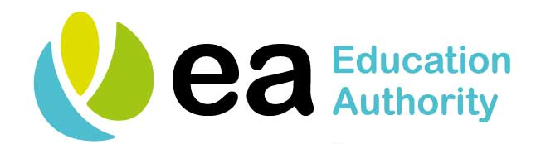
Telephone Support Lines for Young People

Who can  Help? | What Do  They Do? | What Topics Can They  Help With? | How Can They be Contacted?
INSPIRE Students | INSPIRE provides advice on how to help and support pupils/ students. | Mental Health  Alcohol and Drugs  Money  Exams  Relationships  Identity | 02890328474
Lifeline | Crisis response line for people in distress or despair | Depression  Mental health  Suicidal thoughts  Textphone users (for deaf and hard of hearing): | 08088008000  18001 0808808800
Childline | Childline provides support and guidance on multiple topics including: | Bullying  You and your body  Home and Family  Relationships  Sex  School | 0800 1111  www.childline.org.uk  1-2-1 counsellor chat
The MIX | Crisis messenger text service | Alcohol  Homelessness  Suicidal thoughts  General advice  Mental health  Sex/ relationships | 08088084994
NSPCC | Advice on safeguarding and child protection issues and somewhere to report concerns  Web support for teenagers | Safeguarding  Child abuse  Child protection | 08088005000  www.there4me.com
Aware | Aware is a mental health charity working exclusively for those with depression and mental health concerns | Depression  Bipolar disorder | 08451202961
Frank | Confidential advice on drugs | Alcohol  Drugs | 03001236600
SIMON Community | Support for individuals and families who are at risk of becoming homeless | Homelessness  Housing | 08001712222
Family Planning Association | Advice on sexual health | Sexual health  Pregnancy  Contraception  STDs | 03451228687
Domestic and Sexual Violence Helpline | Advice for anyone affected by domestic and sexual violence | Domestic violence  Sexual violence | 0808021414
The Migrant Centre NI | Financial Health and Well being |  | 07769903471
Cara-Friend/  LGBT Switchboard NI | Support and counselling for the Gay, Lesbian and Transgender communities | LGBTQ+ advice  Sex and relationship advice | 08088000390
Women’s Aid | Specialist services for women, children and young people who have experienced domestic and sexual violence. | Domestic Violence  Sexual violence  Relationships | 08088021414
Family Support NI | Website to access support in your area – for a wide range of issues – giving local contact details |  | www.familysupportni.gov.uk

