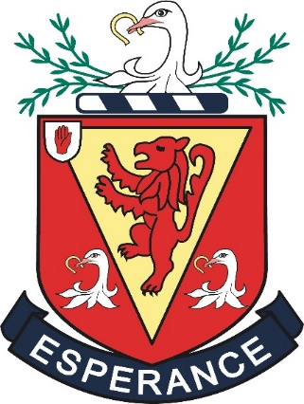

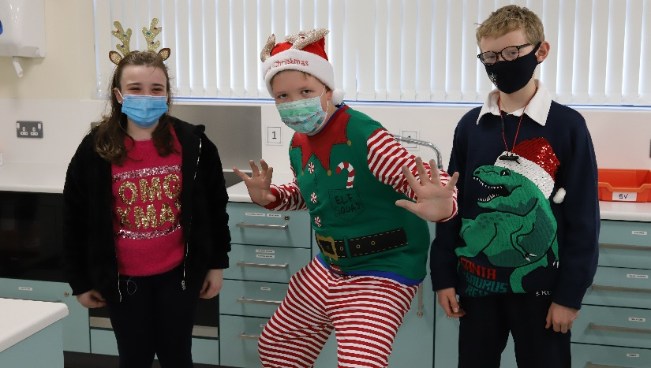
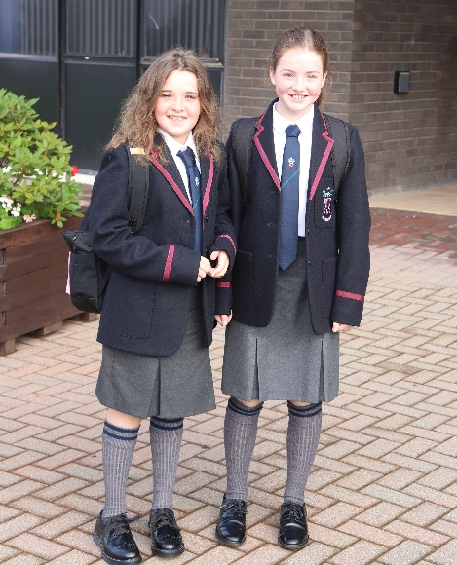
The Wallace High School

Year 8 Pupil Guide 2020
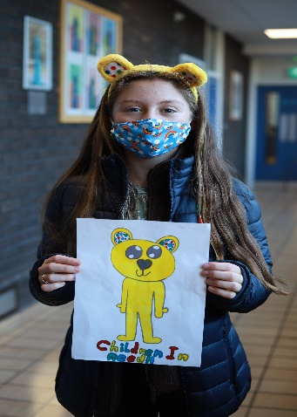
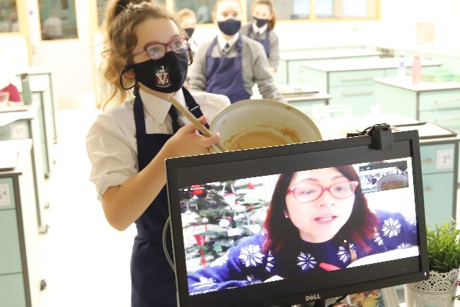

CORE VALUES

A core value is a central belief clearly understood and
shared by every member of the school community.

We believe in:

COMMITMENT

OPPORTUNITY

RESPECT

EXCELLENCE
Boys and Girls

Welcome to the Wallace High School Virtual Open Morning!
This morning you can find out lots about what is like to be a pupil at The Wallace High School. We hope that you enjoy your visit and we would be delighted to welcome you back in September as a Year 8 pupil.
As you explore the school, you will no doubt have many questions in your mind. In this booklet you will find answers to some of the most frequently asked questions about The Wallace High School.
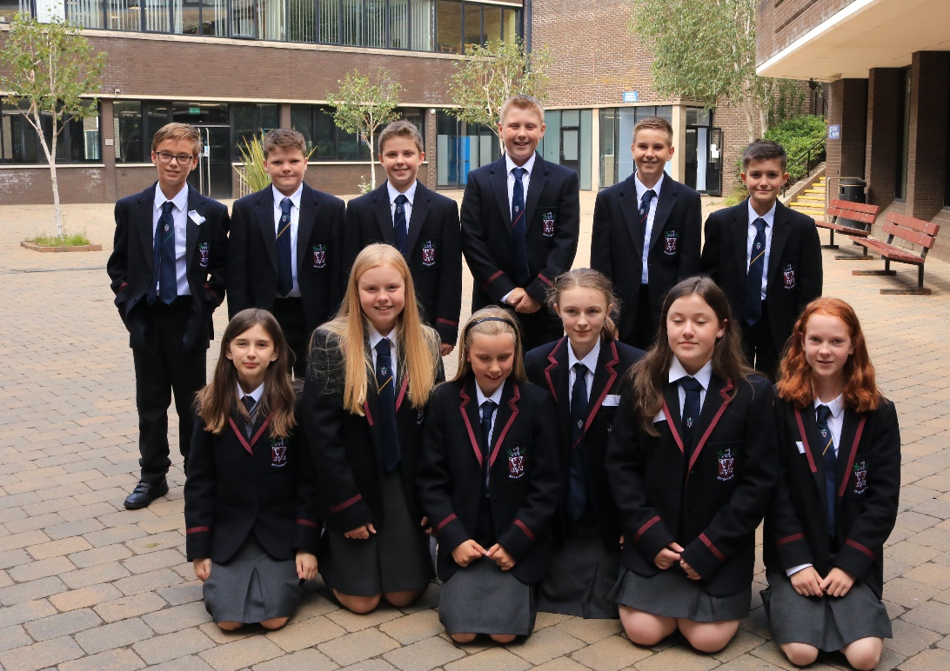

Year 8 Subjects
Computing Mathematics History
Art and Design Geography
Science Games French
Home Economics Music
Physical Education Philosophy Technology
English Learning for Life and Work Drama
In Year 9 you will have the opportunity to study Spanish or German.
Your Questions
Answered
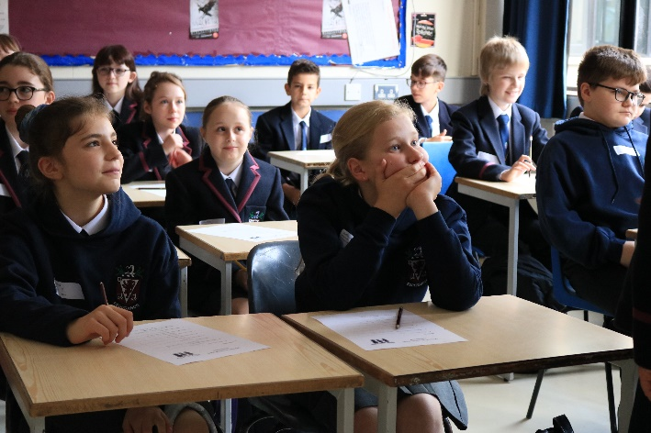

Question: In Year 8 do I study all my subjects with the same teacher?
Answer: No, this is perhaps the biggest change from being in Primary School. In Secondary School you have a different teacher for each subject and you move from room to room at the end of each lesson.

Question: Will I get homeworks?
Answer: Homework is set so that you can practise work you learn in class or complete activities started in class. In Year 8 you will have 3 or 4 homeworks most evenings and each should take about 20 minutes to complete.

Question: Will I have to work hard?
Answer: All we ask is that you do your best! Some pupils find school work easy, others find some subjects more difficult. However, everyone has to work hard to produce their best work.

Question: Will I have exams?
Answer: You will get regular class tests throughout the year. In addition exams are held in January and May. Tests and exams help you, your teachers and parents to see how well you are doing. Twice each year your will receive a report on your progress.

Question: How will I carry all my books around school?
Answer: You will not need to. Shortly after the start of term you will be given the opportunity to hire a locker. You can use it to store your books, PE kit and packed lunch.

The Form System
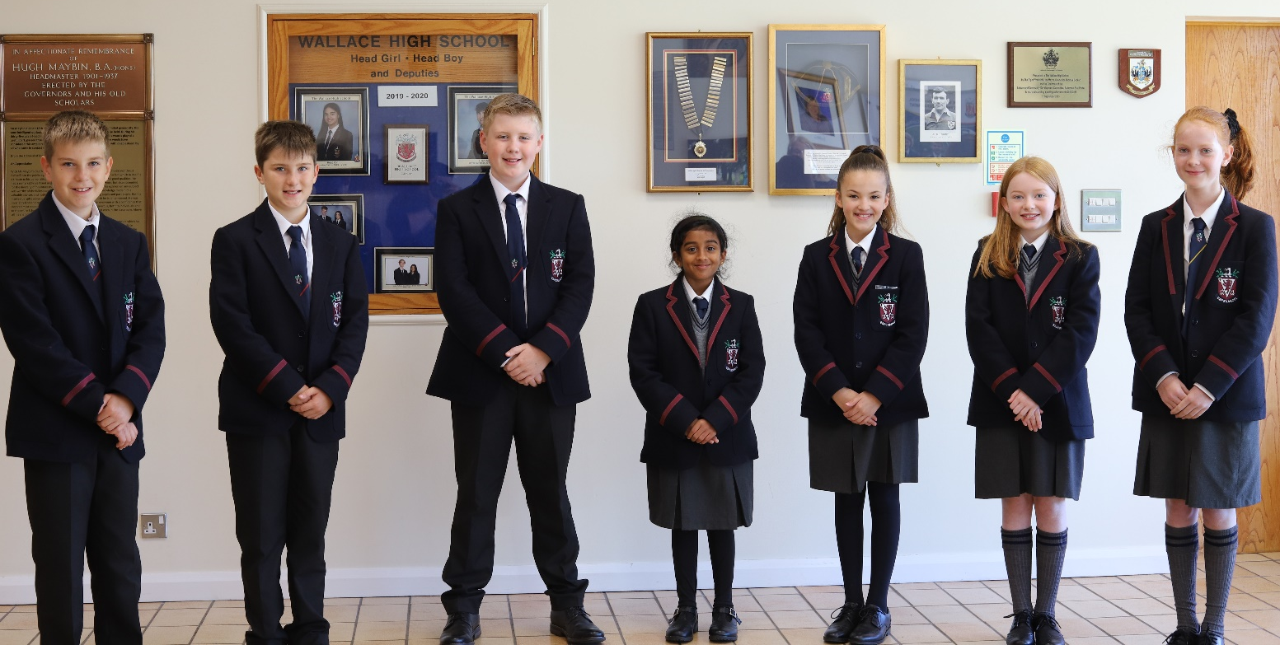

As a Year 8 pupil you will be looked after by a Head of Year and an Assistant Head of Year who have overall responsibility for the welfare and progress of all the pupils in the year. Year 8 is arranged alphabetically into 6 classes. A Class Tutor will look after each class of 28 to 30 pupils. You will see your class tutor each morning for registration and he/she will give you advice and support to help you settle into Year 8.

Question: What happens if I become ill in school?
Answer: A fully qualified Nurse is employed by the school to provide first aid if you are injured in any way and she will also help if you become sick at school, looking after you until an adult can com to take you home. However, she cannot assist any pupil who has become ill at home or outside school hours.

Question: What do I do if I have a problem in school?
Answer: Generally, Year 8 pupils have very few problems but if you are experiencing difficulty, there are lots of people in school who will help you. The first teacher that you will get to know well is your Class Tutor, but other people will be available to help you, for example your Head of Year, Assistant Head of Year, Head of House and the School Nurses, as well as all of your teachers.
The House System

Girls’ Houses | Boys’ Houses
Hanna | Barbour
Gracey | Conway
Seymour | Hamilton



Every pupil is a member of a School House – there are three Girls’ Houses and three Boys’ Houses, each with pupils from Year 8 to Year 14. The House System gives lots of opportunities for pupils to join in a wide variety of sports and other activities. Mr Simpson is in charge of Boys’ Houses and Miss Frey of Girls’ Houses.
The Houses compete against each other in a whole range of competitions, both sporting and non-sporting, arranged throughout the year. At the end of the year the points awarded are added up and House Cups are presented to the winning Girls’ and Boys’ Houses.

Question: What is a School House and where is it?
Answer: A school House is not a building! It’s simply a group of pupils and you will be allocated to one of six Houses. If you have a brother or sister at school, you will belong to the same House as he/she does.

Question: Can I get involved in helping others?
Answer: In 2019-20 our fund raising was interupted by Lockdown, but by March we had already managed to donate £7,000 to the Cancer Fund for Children, £1,500 to Children in Need, over £1,000 each to the Salvation Army and the Simon Community and £2,150 for Cystic Fibrsis research at QUB. We also raised smaller sums for a range of charities totalling several thousand pounds. During the Lockdown, our Technology teachers made PPE (visors) and our Just Giving Page for NHS Charities was warmly supported allowing us to donate £8,500 to the Ulster Hospital, Dundonald.

Sport at Wallace

Question: What Sports and Games can I play at Wallace?
Answer: At Wallace there are more opportunities to get involved in a wider variety of sports than in Primary School. You will be timetabled to have 1 class of P.E. each week and 2 periods of Games every Friday. After school extra coaching is available in certain sports for Year 8 pupils.
Pupils are given the chance to try: Athletics, Badminton, Cricket, Cross-Country, Gymnastics, Hockey, Netball, Rugby, Swimming and Tennis.
You will be encouraged to play on teams either representing your House, your Year or The Wallace High School. Who knows? Perhaps you may even represent your country!
Each year the school is represented by approximately: 12 Rugby Teams, 12 Girls’ Hockey Teams, 6 Boys’ Hockey Teams, 10 Netball Teams, 8 Badminton Teams and in Swimming and Equestrian events
And during the Summer Term by: 7 Boys’ Cricket Teams, 2 Girls’ Cricket Teams,

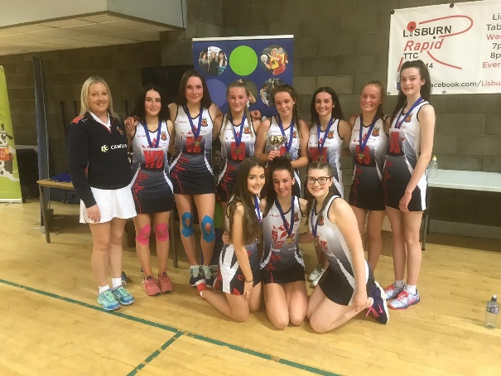
6 Tennis Teams and in Athletics

Northern Ireland Schools’ Ulster Bank Schools’ Cup
Netball Finals 2019-20 Joint-winners 2019-20

Question: How good is Wallace at Sport?
Answer: The standard achieved by many teams is very high. Individual pupils have represented Ulster and Ireland in Hockey, Rugby, Cricket, Athletics, Netball, Badminton and Swimming. However, most pupils simply enjoy themselves by giving of their best.

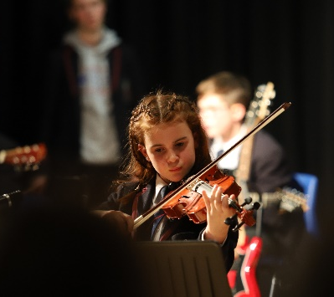
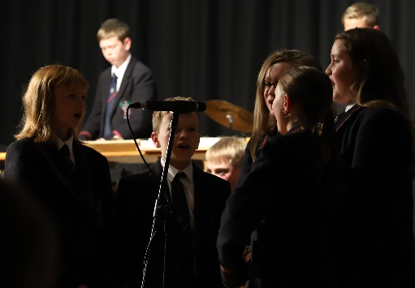
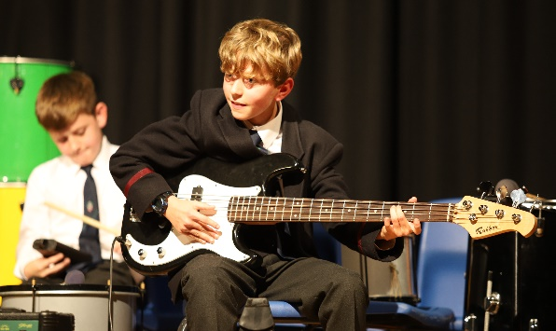
Music at Wallace

The Music Department boasts many choirs, orchestral groups, a guitar club, a jazz group and a piano club. The choirs have toured all over the world, from the USA to the Czech Republic, most recently to sing services in Corpus Christie College, Cambridge. The orchestra perform locally on a regular basis in the island Arts Centre, for the PSNI and at the Royal Victoria Hospital for sick children.
This year over 150 pupils have lessons in a wide variety of instruments including brass, strings, woodwind, guitar, voice and piano.
All Year 8 pupils present a performance evening during the Autumn Term.

Question: Can I get involved in Music?
Answer: The Wallace High School’s Music Department encourages enjoyment and performance of a wide variety of music, from classical to pop. The school choirs jointly have a membership in excess of 180 pupils. Year 8 pupils will be encouraged to join Cantabile which is open to all pupils regardless of experience. This choir practises before school each Friday and takes part in several performances each year.
Question: Can I start to learn to play a musical instument?
Answer: Yes, if you are interested you will be encouraged to take up an instrument. Music scholarships and instumental hire services are also available.
Question: Can I continue learning the instument I played at Primary School?
Answer: Yes, the teachers in the Music Department will be very keen to find out if you play an instrument already and will encourage you to develop your skill. We can often provide an instrument.

Clubs and Societies
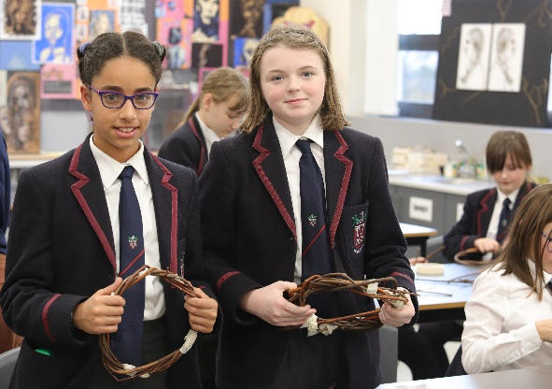
School life is not all about studying and
homeworks. You will be encouraged to take
part in a wide range of clubs and societies.
This is an ideal way to make friends and
develop an interesting and enjoyable hobby.
Most clubs and societies meet after school
or sometimes at break or lunchtime.
Question: What clubs and societies can I join?
Answer: Here are just some of the clubs which welcome new members from Year 8. This varies slightly from year to year.
Art Club Eco Club Junior Scripture Union
Cantabile (Choir) Junior Book Club Minecraft Club
Chess Club Junior Film Club Song Writing Club
Debating Club Junior Languages Club Technology Club
Opportunities for older pupils include:
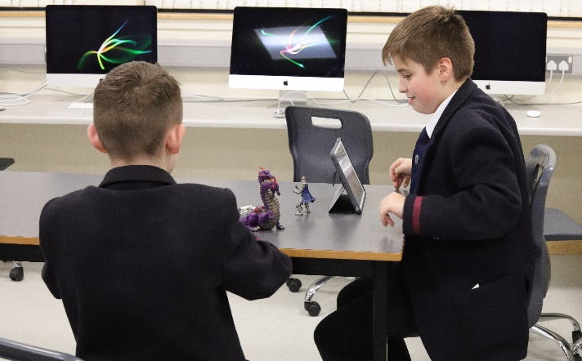
Capella (Choir)
Charity Committee
Community Service Group
Duke of Edinburgh Award Scheme
Honours Music Ensembles
Rotary Interact Club
Senior Debating Society
Ski Club
Question: How can I find out about a club?
Answer: Clubs advertise their activities in morning assemblies and on notice boards throughout the school. At the start of the year you will receive a list of times and venues for each club.
Question: Can I start a new club?
Answer: Yes, new ideas are always welcome, but remember, a teacher must be involved … the staff are very willing to help.
We hope you enjoy your visit to Wallace and that this booklet has answered many of your questions. If you want further information please ask any of the teachers or pupils.
***** To find out more visit us at www.wallacehigh.net *****

