


Downloading your App

Step 1
If you are using an iOS device, go to the Apple App Store and search ‘Safer Schools NI’. If you are using an Android device, go to the Google Play Store and search ‘Safer Schools NI’.

Step 2
Select ‘Download’.

Logging In

Please follow the below instructions.

Creating An Account:

Step 1
If you haven't already, please create an account by clicking 'Parent/Carer' on the login screen of your App.

Step 2
To create an account, click 'Register here' and input your full name, email and password you wish to use. You'll also be asked to confirm your password. Once you're ready, click 'Register' and this will create your account.

Step 3
After you register, you will be asked to read and agree to the Terms and Conditions. After reading and scrolling to the bottom, the ‘I agree’ button will be available to select.

Step 4
When it comes to adding your school, type ‘Department of Education’. Type it in within the search bar and click 'Continue'.

You will then be asked to input an Entry Code. At this point type in the code 4616 and click 'Submit'.

You'll be asked to confirm this by clicking 'Continue'.


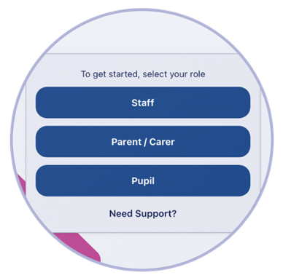
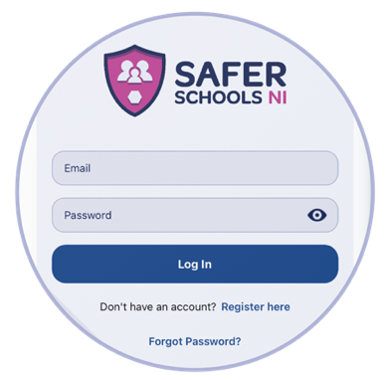

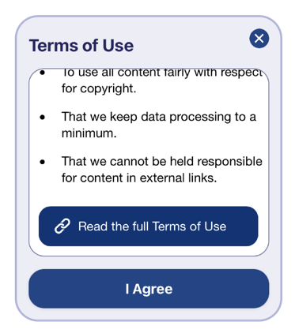
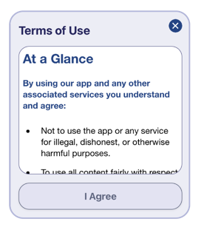

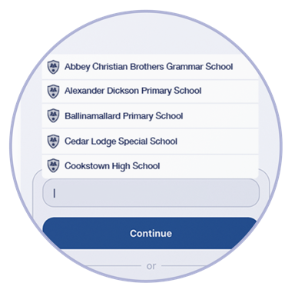
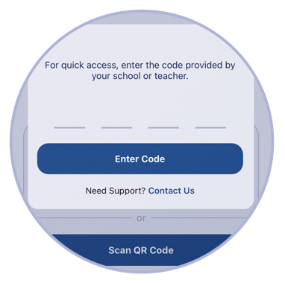

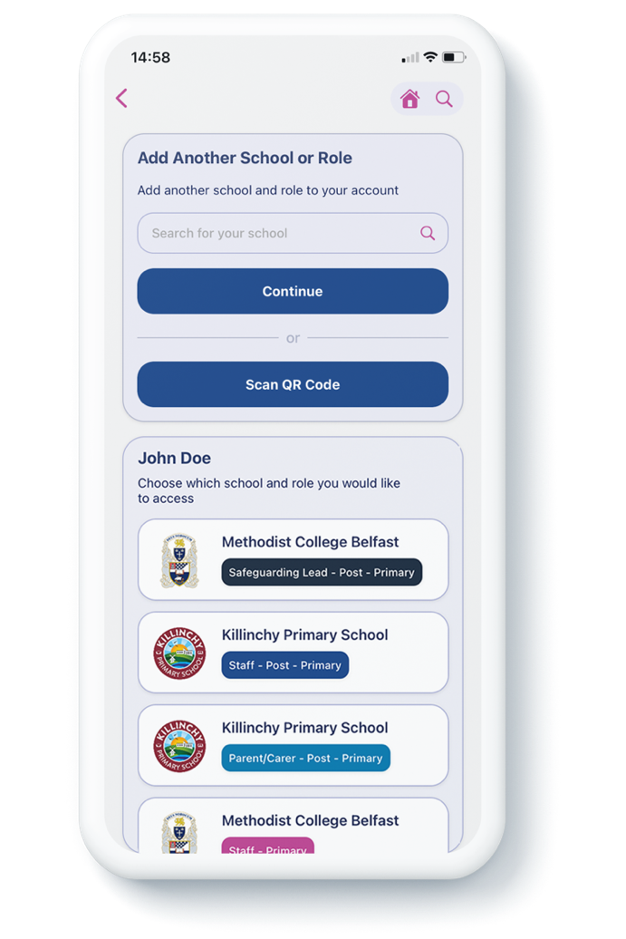

Top Tip: Did you know that your App features Multi-School Login? This means that you are a Staff member in one school with a child in another, or if you are a Parent/Carer of children in different schools, you have access to multiple schools without having to log in and out of the App.

Step 5
To add another School, simply repeat Step 3! You can also view all of your added schools under your name.



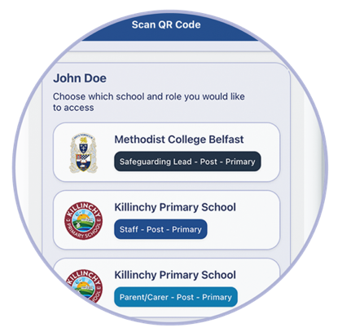
Logging into your App:
Step 1
When you have opened the App, you should input your email address and password that you used to create your account. Once you're ready, click 'Log In'.
Step 2
When you log in, you will see your chosen school(s) that you have added to your account. Simply click the school that you would like to view!

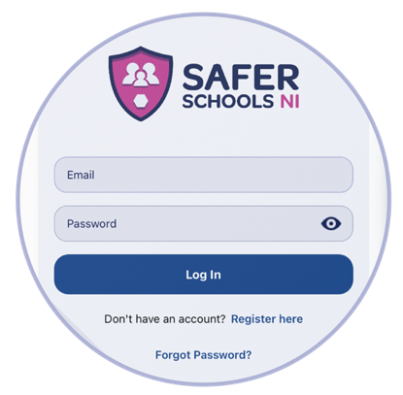

HINT: In the App you should see ‘School News’ with a house icon.

Swipe left twice and this will bring you to the very useful ‘Online News’ section.

